# **A look To the emotional self-management of bullying**

INITIal photovoice

The **Participatory Photography** or **Photovoice** tool is defined as the process by which people can identify, represent, and improve their community through a photographic technique. The main objective of the Photovoice tool is to introduce participating members to active community participation in seeking changes that improve their initial situation.

Applying this to the topic of emotional self-management of witnessed or experienced bullying, the following individual task is proposed. **Each of you will take a photograph focused on or related to one or more of the following three questions**:

1. How do you feel in a bullying situation?
2. How do you perceive your actions in a bullying situation?
3. How do you think you emotionally manage a bullying situation?

People or places must not be identified in the photograph, the anonymity of the participants must be respected, and photographs that are offensive or degrading to any person will not be permitted. The photograph can be taken with a mobile phone or other digital device.

Participation in this activity is **voluntary** and it is required to **sign the consent form** as the photographs and reflections may be used for teaching and research purposes. This activity will be carried out before your arrival in Spain, and then, after the educational intervention, you will be asked for a new activity and participation in a discussion group.

You must send this document in word format (.doc or .docx) together with the signed consent to the following emails before September 9th:

[Sara.fbasanta@udc.es](mailto:Sara.fbasanta@udc.es)

[Maria.jesus.movilla@udc.es](mailto:Maria.jesus.movilla@udc.es)

Below is the space where you can insert the image and the SHOWED Script. This script presents a series of questions that will allow you to explain the photograph taken based on the questions presented.

Put your creativity to play!

1. **DIMITRA SALMATANI**

Include your photograph in JPG or TIFF format here:

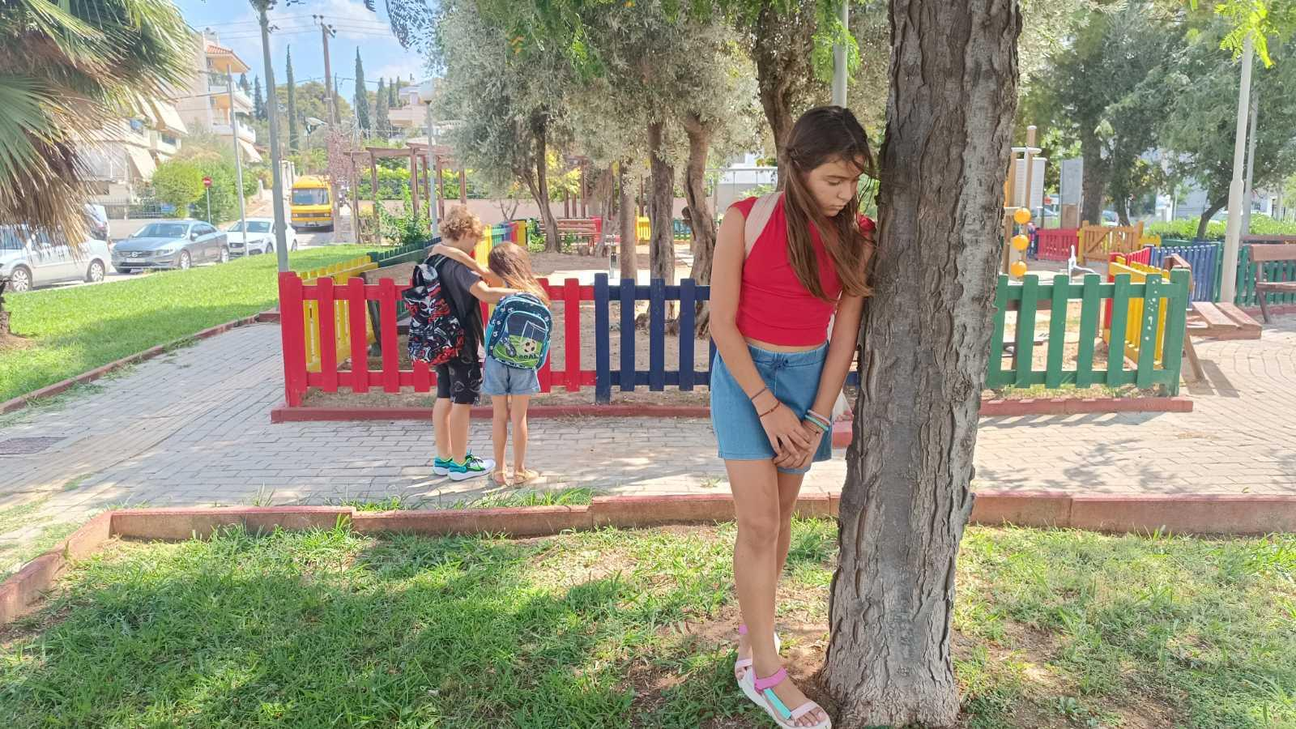

| **SHOWED** (See, Happening, Our community, Why?, Educating, going to Do), (Adapted of Shafer, 1983)  **Author of the photograph: Salmatani Dimitra**  **Gender:woman**  **Educational level at which you teach:seconadary education**  **Photo title: You’re an outsider**  **Place, date and time of photography:Athens, Sunday 1 September 2024**   | **S** | **What do you see in the photo? (Describe what you see)** | | --- | --- | | In this foto i see a teenage girl being marginalised by a group of children. | | **H** | **What is happening? (The real “Story” behind the image)** | | *Τhe students, with their school bags on their backs, are in the playground, probably after school. A group of children, hugging and happy, excludes a classmate from the group and leaves her alone. The teenage girl feels rejection with her body and her gaze showing sadness and low self-esteem.* | | **O** | **How does this relate to our life/health? (Mine and/or that of the people around me)** | | *During high school studies, phenomena of social isolation are observed among home groups. For the sensitive period of adolescence, when the acceptance of the teenager by the whole is of utmost importance, his uneven inclusion in the groups of interlocutors and the consequent social isolation seriously affects his mental health and his academic performance.* | | **W** | **Why do you think this situation that you have photographed exists?** | | *School violence is a multifactorial phenomenon. It starts with the family, which does not give due importance to the moral education of children, as a result of which they more easily become abusers.Τhen, the educational system, especially in Greece, focuses mainly on the transfer of knowledge and the completion of the curriculum and less on the social and moral education of students. The so-called soft skills are in a subordinate position. conservative teaching methods and the minimal application of innovative programs and teaching methods contribute to this.* | | **E** | **How can this photo educate people? (What message can it give)** | | This particular photograph can contribute to the naming of the phenomenon of school violence, to its easier understanding by the public, to the mobilization of the parties involved and, finally, to the design of tools and methods to combat it. | | **D** | **What can we do about it?** | | *We as teachers can highlight the scourge of school bullying, be trained by competent bodies, cooperate and implement actions and programs to prevent and combat the phenomenon.* | |  |  |
| --- | --- | --- | --- | --- | --- | --- | --- | --- | --- | --- | --- | --- | --- | --- | --- | --- | --- | --- | --- | --- |

1. **NATASSA (ANASTASIA) VALMA**

Include your photograph in JPG or TIFF format here:

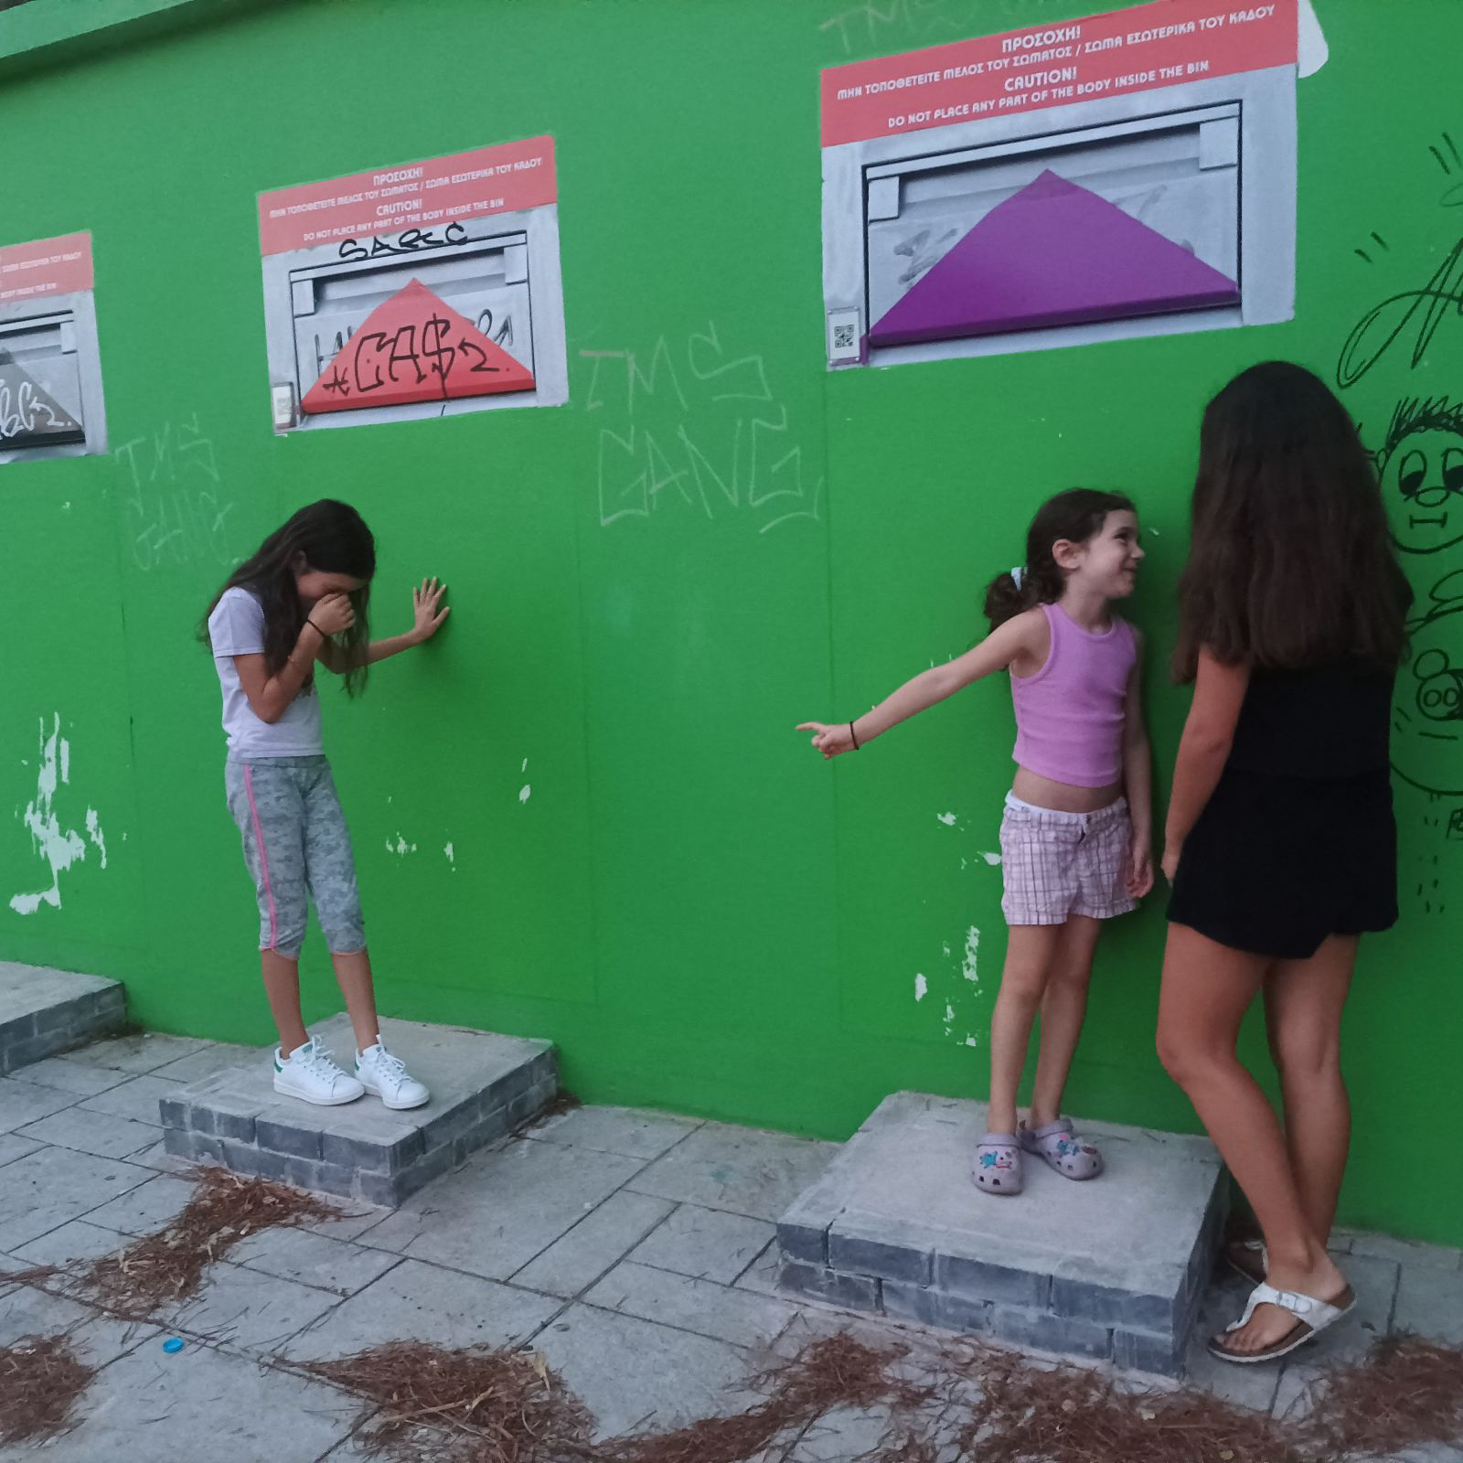

| **SHOWED** (See, Happening, Our community, Why?, Educating, going to Do), (Adapted of Shafer, 1983)  **Author of the photograph: Natasa Valma**  **Gender:woman**  **Educational level at which you teach: seconadary education**  **Photo title: You don’t belong with us!**  **Place, date and time of photography: Greece-Piraeus, 6/9/2024, 19.30**   | **S** | **What do you see in the photo? (Describe what you see)** | | --- | --- | | A girl is excluded and insulted. | | **H** | **What is happening? (The real “Story” behind the image)** | | Students of different ages and classes participate in an environmental activity in the park near their school. They have to separate paper, glass and plastic. The girl on the left wants to be in the “paper” team, but the other two girls make fun of her for the way she looks. The girl was fine, she is well dressed, she is polite. She used to be part of a team… but the last month something has changed. She can’t make sense why this is happening… | | **O** | **How does this relate to our life/health? (Mine and/or that of the people around me)** | | Childhood and adolescence can be really hard. Beside our family, we need friends. A child or a teen that feels not accepted or insulted may face emotional and mental problems. During this period we develop our self confidence, our self esteem. So, it is crucial to have good friends and acceptance while you get older! | | **W** | **Why do you think this situation that you have photographed exists?** | | During school time teens become fashionable, awkward, famous, anxious, strange… all these different situation give them the “ticket” (or not) to enter in the friendship train. Some students get the ticket for being part of a group, some other not. | | **E** | **How can this photo educate people? (What message can it give)** | | “One picture is a thousand words” as we say in Greece. This photo gives the opportunity to other children to put themselves in the shoes of the girl who is bullied. It is a good chance to start conversation about feelings. | | **D** | **What can we do about it?** | | We can make a safe space in the class to discuss how we feel about being excluded. |  1. **MARIA AVLAMISOPOULOU**   Include your photograph in JPG or TIFF format here:     | **SHOWED** (See, Happening, Our community, Why?, Educating, going to Do), (Adapted of Shafer, 1983)  **Author of the photograph: Avlamisopoulou Maria**  **Gender:woman**  **Educational level at which you teach:primary education**  **Photo title: Verbal abuse**  **Place, date and time of photography: Athens, 5 June 2024 14.15 p.m**   | **S** | **What do you see in the photo? (Describe what you see)** | | --- | --- | | In this photo I can see a young boy who is covering his ears with his hands.He is in the corridor out of his judo classroom. | | **H** | **What is happening? (The real “Story” behind the image)** | | The judo class has just finished, during which the boy and his classmates played a judo match. According to his classmates, the boy’s performance was poor, so they started shouting and laughing at him.The boy feels extremely disappointed and rejected by his peers. | | **O** | **How does this relate to our life/health? (Mine and/or that of the people around me)** | | Verbal abuse can have a significant impact on a child’s overall well being. Constant exposure to negative and hurtful words can lead to low-self esteem, anxiety, depression, and other mental health issues. Additionally, children who experience verbal abuse may face difficulty in forming and maintaining healthy relationships, both in childhood and later in life. Overall, verbal abuse can have long -lasting effects on a child’s life, health and well-being | | **W** | **Why do you think this situation that you have photographed exists?** | | Verbal abuse from children can exist for a number of reasons. To begin with children may learn and mimic verbally abusive behaviour of parents, siblings, or other influential figures in their lives. Also children who are experiencing emotional distress may resort to verbal abuse as a way to cope with their feelings. | | **E** | **How can this photo educate people? (What message can it give)** | | This photo can raise awareness about the prevalence and impact of verbal abuse , especially towards children. Besides this, the photo can highlight the damaging effects of verbal abuse on a child’s confidence and mental health. | | **D** | **What can we do about it?** | | There are several steps that can be taken to prevent verbal abuse. It is important for children to be able to recognise the signs and speak up and assert their boundaries. Children should let the abuser know that their behaviour is not acceptable and that they will not tolerate being treated in that way. It can be helpful to seek support from friends, family, a therapist or a support group if they are experiencing verbal abuse. | |  |  | | --- | --- | --- | --- | --- | --- | --- | --- | --- | --- | --- | --- | --- | --- | --- | --- | --- | --- | --- | --- | --- | |  |  |
| --- | --- | --- | --- | --- | --- | --- | --- | --- | --- | --- | --- | --- | --- | --- | --- | --- | --- | --- | --- | --- | --- | --- | --- | --- | --- | --- | --- | --- | --- | --- | --- | --- | --- | --- | --- | --- | --- | --- | --- | --- | --- |

1. **OLGA BLETSI**

Include your photograph in JPG or TIFF format here:

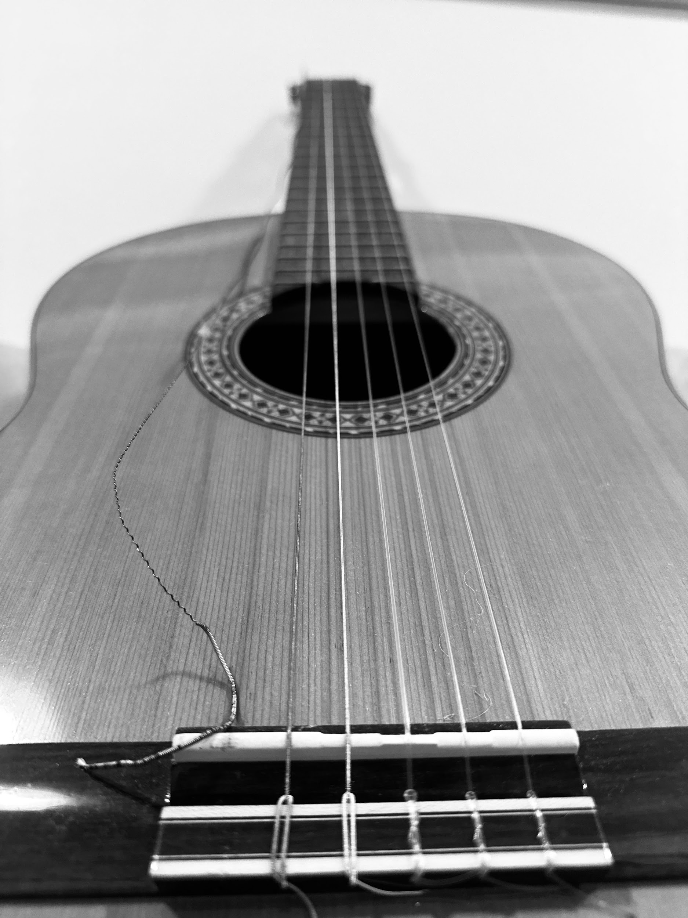

| **SHOWED** (See, Happening, Our community, Why?, Educating, going to Do), (Adapted of Shafer, 1983)  **title of the photo:**  **Author of the photograph: Olga Bletsi**  **Gender:woman**  **Educational level at which you teach:seconadary education**  **Photo title: The broken string**  **Place, date and time of photography: Athens, 7/9/2024, 21:30**   | **S** | **What do you see in the photo? (Describe what you see)** | | --- | --- | | In this photo there is a guitar with a broken string. | | **H** | **What is happening? (The real “Story” behind the image)** | | Guitar is a musical instrument with 6 strings. The last one is the most sensitive and thin due to its construction material. So, when we play and apply the same pressure to all of them, it’s usual that the weaker ones are being broken. | | **O** | **How does this relate to our life/health? (Mine and/or that of the people around me)** | | The broken string could be compared to all those who have been bullied because of their sensitivity. Even in school, the introverts and gentle students are becoming a figure of fun by others. | | **W** | **Why do you think this situation that you have photographed exists?** | | When a guitar string gets broken, we have two options: we can replace it with a new string or fix and reinstall the broken one. In a situation of social marginalisation, people either edge somebody out or they try to embrace them. | | **E** | **How can this photo educate people? (What message can it give)** | | This photo provides thought provoking information for people who have mistreated somebody or for those who have been physically and mentally abused. Every single string of the guitar plays its unique role to create a harmonic melody. If -at least- one is missing, we’ll have an incomplete and discordant sound. Therefore, when it comes to the daily life, people have to understand that the “broken ones” are equal and important. Any of us is an intimate part of life, regardless of age, gender or personality. | | **D** | **What can we do about it?** | | We, as teachers and educators, have to inculcate the right values to our students about respect, empathy and acceptance. | |  |  |
| --- | --- | --- | --- | --- | --- | --- | --- | --- | --- | --- | --- | --- | --- | --- | --- | --- | --- | --- | --- | --- |

1. **FRANCESCO CASSANO**

Include your photograph in JPG or TIFF format here:

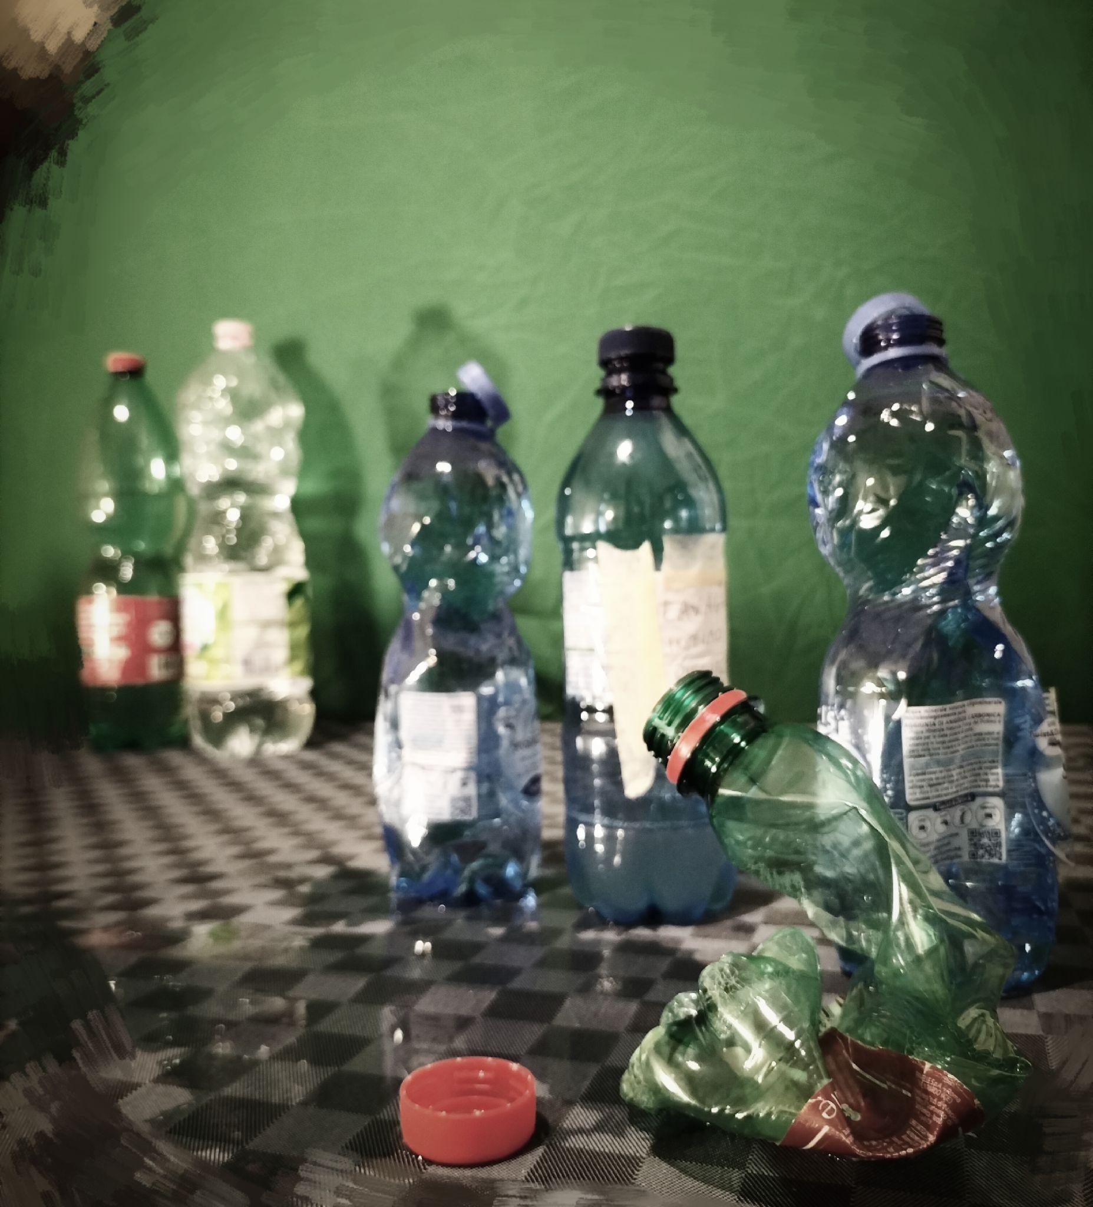

**SHOWED** (See, Happening, Our community, Why?, Educating, going to Do), (Adapted of Shafer, 1983)

**Author of the photograph: Cassano Francesco**

**Gender: Male**

**Educational level at which you teach: Secondary Education  
  
Photo title: Emptied**

**Place, date and time of photography: Taranto, 9 September 2024 13.00 p.m.**

| **S** | **What do you see in the photo? (Describe what you see)** |
| --- | --- |
| A group of little bottles surrounds an emptied little bottle amidst the indifference of “its parents” |
| **H** | **What is happening? (The real “Story” behind the image)** |
| There is a "different" bottle from the group. The other components, in order to "fill" themselves, decide to swell, emptying those they perceive as different. |
| **O** | **How does this relate to our life/health? (Mine and/or that of the people around me)** |
| How can a person feel cornered and branded as different if not emptied and humiliated?  What can the ego of its encirclers be nourished by if not by its deepest lifeblood, that is, shattered self-love and dignity?  What remains of the well-being and health of those who suffer all this?  I believe that each metaphor used in this narrative can give an idea of ​​what it might feel like to experience a bullying situation |
| **W** | **Why do you think this situation that you have photographed exists?** |
| Because these situations often occurred before everyone's eyes and were too often ignored by those who could have done something to change this picture. |
| **E** | **How can this photo educate people? (What message can it give)** |
| Let's look at this picture carefully and try for a moment to immerse ourselves in it, to experience what the empty bottle feels like |
| **D** | **What can we do about it?** |
| Let us not also become bottles in the background because by taking just a few steps towards those who are more fragile we have the possibility of bringing a small but decisive change in the meaning of the painting. An adult in the foreground defuses bullying |